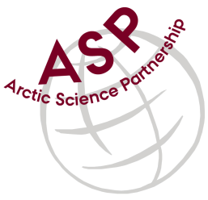

Minutes from ASP Laboratory Team Meeting

Date: February 10th, 2021
Present: Anette Rasmusssen (AU), Else Ostermann (GNI), Emil Munk (GNI), Karley Campbell (UT), Marie-Hélène (UL), and Marcos Lemes (UM)
Absent: Egon Frandsen (AU)
Referee: Marcos

Thank you all for joining the ASP Lab Team meeting. This is meeting has been taken online.

Members discussed further how collaborate among the network.

Else (GNI) introduced Emil Munk to the group. Else suggested to add pictures of the analytical instrument that will be posted at ASP’s website. Also suggested to use a standard unit for the analyses done in the network.

Marie- Hélène (UL) suggested to expand the group for who goes to the field in order to coordinate a standardization of sampling procedures (e.g.: sampling same water depth), and also suggested to create a SOP for field sampling.

Karley (UT) suggested to have a workshop during the next general annual meeting to discuss an intercomparison exercise among the network.

Next meeting: Next team meeting will be on March 10th 2021 at 15h00 CET

