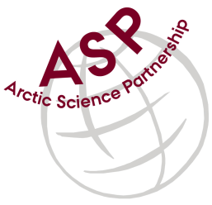

Minutes from ASP Laboratory Team Meeting

Date: March 10th, 2021
Present: Anette Rasmusssen (AU), Egon Frandsen (AU), Karley Campbell (UT), Marie-Hélène (UL), and Marcos Lemes (UM)
Absent: Else Ostermann (GNI), Emil Munk (GNI)
Referee: Marcos

Thank you all for joining the ASP Lab Team meeting. This is meeting has been taken online.

Members discussed further how collaborate among the network.

Karley (UT) suggested to have a workshop during the next general annual meeting to discuss common sampling protocols among the network. Perhaps discussion with PI’s for 1hr during the general meeting and having half day meeting with tech people after the meeting.

The workshop proposal aims to stablish common sampling and analyses protocols and brain storm other collaborations.

Marcos acknowledged receiving labs instrumentation list from the team and he would forward them to all team members after the meeting.

Next meeting: Next team meeting will be on April 7th 2021 at 15h00 CET

