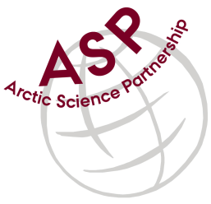

Minutes from ASP Laboratory Team Meeting

Date: April 14th, 2021
Present: Anette Rasmusssen (AU), Egon Frandsen (AU), and Marcos Lemes (UM)
Absent: Else Ostermann (GNI), Emil Munk (GNI), Karley Campbell (UT), and Marie-Hélène (UL)
Referee: Marcos

Thank you all for joining the ASP Lab Team meeting. This is meeting has been taken online.

Members discussed further how collaborate among the network.

With labs instrumentation list from the labs received and distributed among the members, we may start to discuss on how to standardize the SOP. In this meeting was chose a technique (chlorophyll) that most labs have in common. We intend to share all SOPs beforehand the next meeting.

Marie-Hélène sent an email before the meeting started communicating her absence and telling she might have more labs from University of Laval participating.

Next meeting: Next team meeting will be on May 12th 2021 at 15h00 CET

