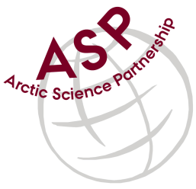

Minutes from ASP Administration-Communication Meeting

Date: May 5, 2021
Present: Egon Frandsen, Dirk Mengedoht, Karley Campbell, Jackie Edelson, and Peter Schmidt Mikkelsen
Referee: Peter

Issues related to ASP:

AWI (Dirk). People on their way to Svalbard for field work. All in quarantine in Oslo. Polar Stern cruise on the way to Fram Strait (June campaign). All other Greenland projects on hold.

AU (Egon) ARC is preparing for the next field season in NE-Greenland. However everything is incertain due to the Covi-19 situation. East coast of Greenland is still closed by the authorities.

CEOS (Jackie). Sam Swanson is no longer with CEOS. There is no replacement for him yet. Field workin Hudson and Cambridge Bays. Churchill opens up in the fall.

Karley (UiT). Field campaigns - Fram center project in Svalbard. ARCTOS PhD course across the Polar front (Helmer Hansen). Despite corona they manage fieldwork.

Next meeting: Next team video-meeting will take place on July 7, 2021 at 15.00 CET.

