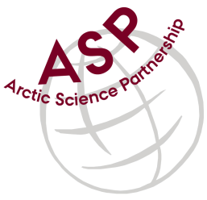

Minutes from ASP Laboratory Team Meeting

Date: December 12nd, 2022
Present: Anette Rasmusssen (AU), Karley Campbell (UT), Marie-Hélène (UL), and Marcos Lemes (UM)
Absent: Egon Frandsen (AU) and Else Ostermann (GNI)

Referee: Marcos

Thank you all for joining the ASP Lab Team meeting. This is meeting has been taken online, resuming from a summer break

Our first inter-laboratorial exercise (Chlorophyll) had a drawback due to samples shipped to Manitoba (with delay), Laval, and Nuuk never arrived. Apparently shipping samples in dry ice has new policies and you got problem to receive them at destinations. Karley suggested to use Dry Shipper for a new shipment attempting. Apparently, Dry Shipper method is not classified as Dangerous Goods, we can ship with simpler paperwork and less cost.

During general meeting Søren’s in January, he suggested to add CTDs calibration in this group. In order to be tested before go to the field. – It was discussed and according to Marie-Hélène, CTDs are calibrated in factory only. It was decided to gather more information from Søren what he has in mind. Small CTDs could be shipped and tested in one place, for instance SERF at UofM. But big ones would be an issue.

Please use Skype link https://join.skype.com/uKv5ArcoaxDw for the meetings

All members agreed regarding the meeting dates; all online meetings will be on second week of each month on Wednesdays at 15h00 Central European Time (CET).

Next meeting: Next team meeting will be on Februay 9th 2022 at 15h00 CET

