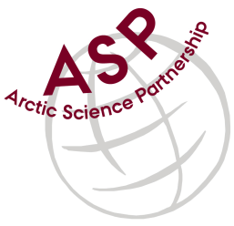

Minutes from ASP Laboratory Team Meeting

Date: June 8th, 2022
Present: Marcos Lemes (UM), Marie-Hélène (UL), and Egon Frandsen (AU),
Absent: Else Ostermann (GNI), and Karley Campbell (UT)
Referee: Marcos

This is meeting has been taken online.

We have discussed below topics:

- Karley sent successfully the chlorophyll samples with a dry shipper to UM. Once received by UM the samples that belongs to UL where resent and received by UL with dry-ice.
- The time to all participants to do analysis where postponed to September because of field work and some instrument will be in the field.
- We have been communicated that Anette (AU) will not participating in this group any longer. She moved to another job.

Please use Skype link https://join.skype.com/uKv5ArcoaxDw for the meetings

All members agreed regarding the meeting dates; all online meetings will be on second week of each month on Wednesdays at 15h00 Central European Time (CET).

IMPORTANT NOTE: Exceptionally the next team meeting will be on September 7th 2022 at 15h00 CET
- We did not have a meeting in last May due to most participants be busy preparing or being in field work

