ASP Chlorophyll a Intercalibration Report

Egon Frandsen (AU), Ilka Peeken (AWI), Karley Campbel (UiT),
Marcos Lemes (UM),Marie-Hélène (UL), and Megan Lenss (UiT)

Introduction and Field

The Arctic Science Partnership (ASP) is a network of universities and institutes that aims to study and monitor the Artic environment. Due the size of ASP network, it has a framework of thematic teams with representatives from each member institution. The Lab Team goal is part of this framework, and it exists to verify the quality of analyses done within the network and improve them wherever possible.

Here we outline an assessment of the pigment Chlorophyll a within the ASP Lab Team, a routine parameter that is central to many studies.

Water samples for this intercomparison were collected from Finnfjord, Norway, October 15, 2021 at approximately 5 m depth by Karley Campbell and Megan Lenss (UiT), using a Niskin water sampler. The collected water was subsequently filtered onto 0.7 um GF/Fs (Whatmann). A number of these GF/F samples were immediately processed for determination of chl a via fluorescence (UiT protocol), while all others were frozen at -80C before shipping to a number of member laboratories via either a dry shipper or dry ice. To account for the possible impact of freezing on sample quality, number of samples were also kept at -80C for later processing. Each lab has different protocols for their chlorophyll a analysis. In order to eliminate one variable, a specific timeframe for all labs to perform all analyses via fluorescence or high-performance liquid chromatography (HPLC). The processing off all frozen samples took place between October 3rd to 14th, 2022.

Methods

Samples collected in Finnfjord, Norway, were sent to five different labs, University of Tromsø (UiT), University of Aarhus (AU), University of Manitoba (UM), University of Laval (UL), and Alfred Wegener Institute (AWI) for Chlorophyll a analysis

The laboratory participants used three different models of fluorometers (Tuner Designs 10U, Turner TD-700 and Triology) and AWI used a Waters Alliance HPLC system with a PDA detector as well for Chlorophyll a analyses. All calibration were performed months earlier than the analysis dates, with exception of UiT for the UiT-T0 analysis. Each laboratory used different calibration range since no laboratory had knowledge on how much Chlorophyll a would be in the filters. Since for HPLC analyses only a small fraction of the sample is measured, the calibration range is much lower compared to the fluorometric measurements. AWI, UiT and AU were the only laboratories with closer calibration range from the sample concentration (average concentration of 0.65 ug/L), followed by UL, Table 1.

Table 1 : Instrument and calibration information used for Chlorophyll a comparison exercise of ASP laboratories
Laboratory | Instrument  (make/model) | Calibration (date) | Instrument moved between calibration and measurement  (Y/N) | Calibration range (ug/L)
AWI | Waters Alliance with PDA | Nov. 2021 | No | 1.6 - 409
AWI | Turner TD-700 | Sept. 2021 | No | 0.005 -1.0
Laval | Turner Designs 10 AU | April 2022 | N.D. | 6.5 to 3000
Manitoba | Turner Designs (Trilogy) | April 2022 | Yes | 20 -250
Aarhus | Turner Designs 10AU | September 2022 | N.D | 2,13 and 426
UiT (Original) | Turner Designs (Trilogy) | Winter 2022 | Yes | 0.5- 200
UiT (2021 Spring Calib) | Turner Designs (Trilogy) | Spring 2021 | Yes | 0.5- 200
N.D.: No data

In Table 2 shows the protocols used for each lab on this experience, there is a large discrepancy on the protocols used among the laboratories, from thawing time (no tawing to 60 min), extraction temperature (-20ºC, +4ºC, and +21ºC) to waiting time before measurement (0.5hr, 1hr, 5hr, and 20hr). AWI and AU do not acidify the samples before measuring.

Table 2: Analytical procedures for Chlorophyll a analysis of ASP laboratories

Laboratory | Thawing time (minutes) | Extraction  (vial type) | Extraction solvent | Extraction time (hr) | Filter treatment | Extraction  Temp  (ºC) | Sample Treat. prior to measurement | HCl conc. | Waiting time before measurement (hr) | Light  environment | Vial type | Vial (single/multi-use)
AWI Turner | No | Precellys tubes (PP) 6ml | Acetone 90% | 0.5 | filter destruction with glass beads in Precellys | -20-0 | Centrifugation at 0°C | 2 drops of 1 molar HCL | 30 min. before centrifuge + 10 min. of centrifuge | Very low artificial light, sheltered from natural light | Precellys (PP) | Multiple
AWI HPLC | No | Precellys tubes (PP)  2ml | HPLC grade  Acetone 100% | 0.5 | filter destruction with glass beads in Precellys | -20-0 | Centrifugation at 0°C | None | Autosampler up to 15 hours  Kept at 4°C | Very low artificial light, sheltered from natural light | Precellys (PP) | Single
Laval | 5 | Borosilicate glass | Acetone 90% | 24 | No treatment | -20 | Shake | 5% | 5 | Green light | ---- | Single
Manitoba | 60 | Plastic with screw | Acetone 90% | 20 | Vortex (few sec) | +4 | No shaking | 5% | 1 | Green light | Borosilic. glass | Single
Aarhus | 30 | Braun centrifuge glass | Ethanol 96% | 12 | Sonicated | +21 | Sonicated, shaken, and centrifugation | None | 20 | dimly natural light | Glass | Multi-use
UiT (Original) | From -80C to -20C for 10 min | Polypropylene  tube (Flacon) | Acetone 90% | 24 | Muddled with glass muddler in falcon tube | +4 | Centrifuged 10 min @ 20°C and 4 rpm | 3 drops of 5% HCl | 30 min. before centrifuge + 10 min. of centrifuge | Artificial light, sheltered from natural light | Borosilic glass | Single use

Data Discussion

Samples collected and sent to participants laboratories for Chlorophyll a analysis, have shown following results, Table 3, and will be discussed below.

UiT has two data sets, UiT-T0 represents the data collected and analyzed immediately after sample collection, with no preservation time of this exercise giving 0.69 ± 0.03 ug/L. UiT also analyzed samples after they were frozen at -80C for similar duration to other ASP labs, and using a different calibration (2021 Spring). During transport to lab facilities, the water samples were kept in darkness. Processing of frozen samples differed slightly from T0, largely in the extent of filter disruption, where the filter of frozen samples was broken-up via muddling. Samples were kept at 4C during extraction, but were otherwise processed at room temperature.

AU analysis was 0.75 ± 0.03 ug/L, the highest concentration in this exercise; the possible reason could be related to solvent used for the Chlorophyll a extraction. AU uses ethanol (96%) and does not acidify the samples differently from other labs that used acetone (90%). Wasmund et al., 2006, have reported a study comparing extraction using 96% ethanol and 90% acetone. Their finds were that there is no significant difference between homogenized and unhomogenized samples if they had been extracted in 96% ethanol. In 90% acetone, however, the chlorophyll a yield was on occasion significantly reduced if the samples had not been homogenized. The extraction efficiency, ethanol and acetone, seems to depend on other factors, such as the taxonomic composition of the algal community. In their experiments, was obtained significantly more chlorophyll a when Phaeodactylum and Microcystis were extracted in ethanol as opposed to acetone. This was also the case with natural populations dominated by diatoms. AWI reported major presence of diatoms on HPLC analysis (not reported at this) and that could explain why UA found higher concentration, Graph 2.

UM and UL have shown similar Chlorophyll a data, 0.58 ± 0.03 ug/L and 0.59 ± 0.02 ug/L, respectively. AWI was the only lab had two different analytical instruments (fluorometer and HPLC) for analysis comparison and the analyses were done at Spring 2022. Fluorometer and HPLC results were similar of each other, 0.68 ± 0.11 ug/L and 0.66 ± 0.11 ug/L, respectively, with results near to UiT-T0. Interesting point, is that AWI’s protocol does not acidify for HPLC analysis but acidify of fluorometer analysis. Although, they showed the similar highest standard deviation (15.7% and 17.1%) from other laboratories. Other labs showed standard deviation less than 5.5% with exception those samples analyzed with different calibration dates from UiT-Spring 2021 (~12%). The overall concentration of Chlorophyll a from the labs is 0.65 ug/L

Table 3: Chlorophyll a analyses from the ASP laboratories.
 | UiT - T0 | UiT-Preserved 2021 Spring | AU | UM | UL | AWI-Fluorometer | AWI-  HPLC
Mean (ug/L) | 0.69 | 0.64 | 0.75 | 0.58 | 0.59 | 0.68 | 0.66
Std Dev (ug/L) | 0.03 | 0.07 | 0.03 | 0.03 | 0.02 | 0.11 | 0.11
Rel Std Dev (%) | 3.8 | 11.8 | 3.7 | 5.5 | 2.8 | 15.7 | 17.1
UiT: University of Tromsø; AU: University of Aarhus; UM: University of Manitoba; UL: University of Laval; AWI: Alfred Wegener Institute

The calibration range from the labs may have influenced the data precision of the analyses, as in Graph 1. The UiT (2021 Spring) and the AWI-HPLC were the only analysis batches that the average concentration is very near with calculated mean concentration from all samples (dashed line), followed by AWI-HPLC. AU had the smallest variability but had an outlined as well, but AU data showed highest average concentration of all laboratories

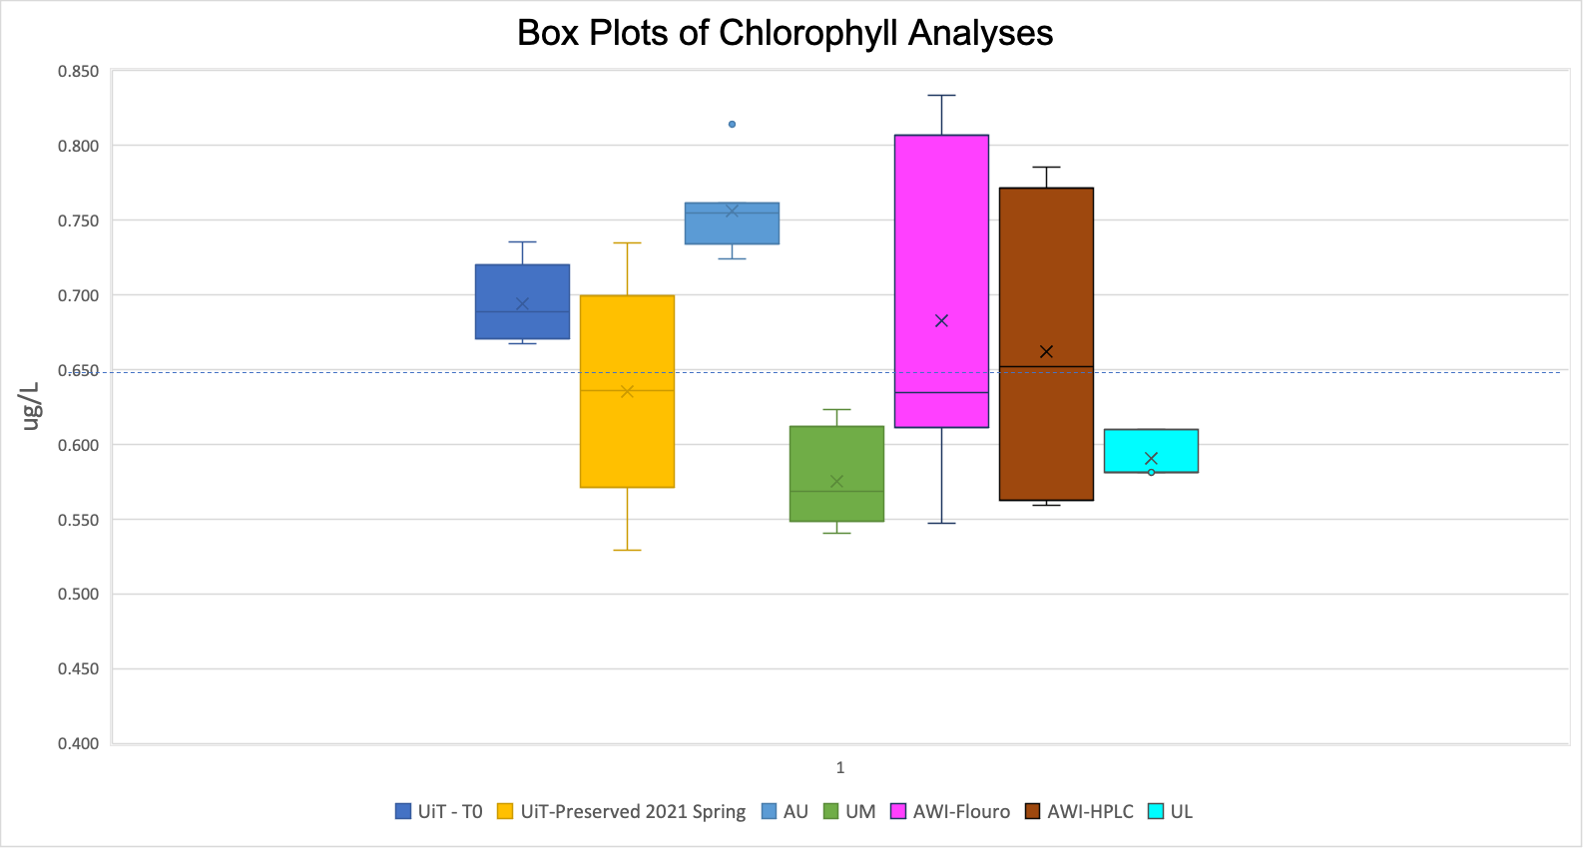
Graph 1: Chlorophyll a data from the five ASP labs

The results could be interpretated by two viewpoints in this exercise. The first viewpoint, would be using UiT-T0 as a reference, due to the samples were analyzed within the shortest period of time from the sampling. The second viewpoint, would be using the data provided by analyses from HPLC from AWI. The two viewpoints will be discussed below.

Taking the results of UiT-T0 as reference (Graph 2), due to the samples were collected and analyzed right way. The majority of laboratories showed loss of Chlorophyll a compared to UiT-T0 in absolute value, with exception of AU that showed an increment of concentration of 0.06 ug/L in average concentration. AWI-Fluor showed the closest difference with loss of 0.01 ug/L and 0.03 ug/L for AWI-HPLC. Other laboratories showed losses of 0.10 ug/L (UL), 0.12 ug/L (UM). UiT performed analyses with same samples with different calibration dates giving losses of 0.06 ug/L (UiT -2021 Spring).

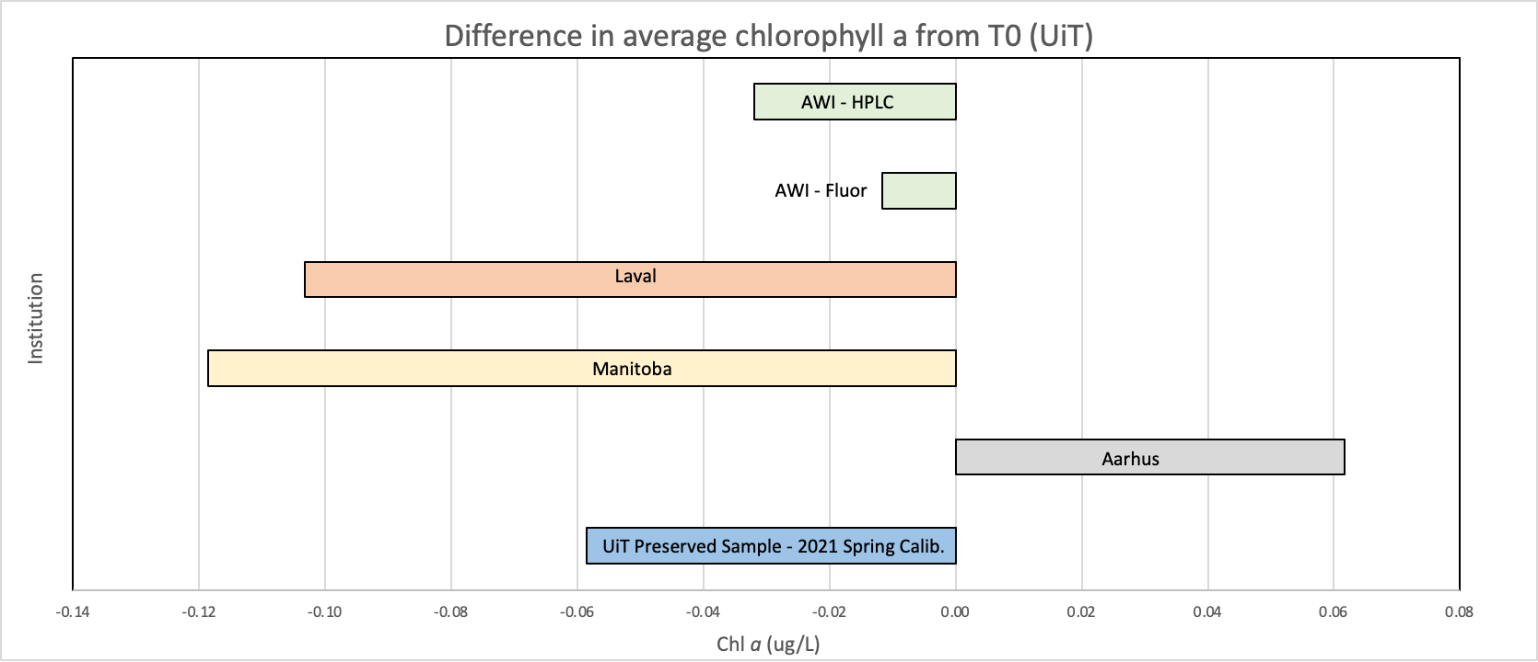
Graph 2: Difference in average chlorophyll a from T0 (UiT)

The second viewpoint, would be using the data provided by analyses from HPLC from AWI. It has been suggested that the analysis of Chlorophyll a by HPLC is more accurate method than fluorometer (Bidigare, R., 1991). In Graph 3, is shown the Chlorophyll a data analyzed with fluorometers compared to a HPLC. AU, UiT-T0 and AWI-Fluor, that had increment of concentration of 0.09 ug/L, 0.03 ug/L, and 0.02 ug/L. Other laboratories had loss concentration from HPLC are: UiT-2021 Spring with loss of 0.03 ug/L of chlorophyll a, UL lost 0.07 ug/L, followed by UM 0.09 ug/L. In this experiment we had three data set with loss less than 13% in concentration and three data set with increment of concentration up to 14% when is compared to HPLC.

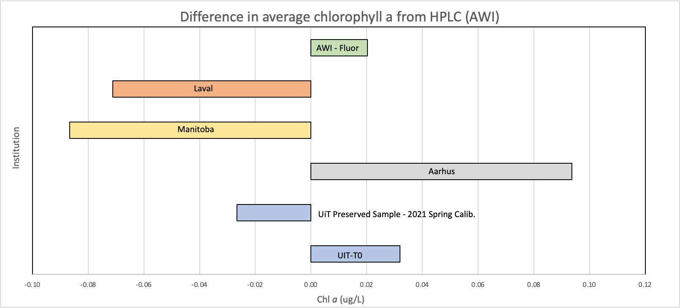
Graph 3: Difference in average chlorophyll a from AWI-HPLC

Conclusions and Recommendations

The data presented in this report suggests that the chlorophyll a is potentially affected by one or a combination of the following: preservation duration, transportation, temperature of filter processing as well, and cleanliness of glassware.

The Graph 1 suggests the analysis timing or transporting may influence the integrity of chlorophyll a. The laboratories UL and UM has shown concentration mean below the average concentration (0.65 ug/L) followed by UiT Spring 2021. Other laboratories closer from collection sites (AWI, AU, and UiT) presented concentrations above average concentration. We recommend to analyse the samples as soon possible in order to avoid sample degradation. Even using a dry shipper for long distance is likely to affect the integrity of the sample. Similarly, it seems optimal to complete all processing of chlorophyll a sample at temperatures of 4 ºC or colder, until samples are warmed to a consistent temperature for fluorescence measurements.
Values of chl a may be affected by artifact of glassware when re-using. Here, we recommend that fluorometer vials to be properly cleaned (eg.: acid washed, thoroughly rinsed and added into fume oven).

Despite most calibration curves were not in range the collected sample concentrations, the data from participant laboratories have shown a fair precision. The data have shown that fluorometer has sensitivity for low concentration chlorophyll a. We would like to recommend to improve the chlorophyll analysis:
- Preparing the calibration curve that fits samples concentrations for better precision;
- For calibration of the Turner fluorometer we recommend the following treatment of the chlorophyll a standard. We suggest to estimate the concentration of the standard from stock solution, the absorbance should be measured using a spectrophotometer and calculate its concentration using the equation provided in Roy et al. (2011). Chlorophyll-a concentration can sometime be quite different from the concentration indicated on the standard description.
- Also, we would like to recommend calibration and analysis not be far apart each other.
- Further work on impact of chl a standard on calibration is required.

Acknowledgments

We would like to thank ASP network for the support in this inter-calibration exercise. We appreciate the ASP network (S. Rysgaard) in purchasing the dry shipper, without it, would not be possible for Canadians laboratories receive the intact samples.

We recognize and thank the analysts who did the chlorophyll analyses, some are in this report others are not.

References

Bidigare, R. (1991). in Spencer and Hurd (eds.). The analysis and characterization of
marine particles. American Geophysical Union, Washington D.C.

Roy, S., Llewellyn, C., Egeland, E., & Johnsen, G. (Eds.). (2011). Phytoplankton Pigments: Characterization, Chemotaxonomy and Applications in Oceanography (Cambridge Environmental Chemistry Series). Cambridge: Cambridge University Press. doi:10.1017/CBO9780511732263

Wasmund, N., Topp, I, and Schories D., 2006. Optimising the storage and extraction of chlorophyll samples. Oceanologia, 48 (1), pp. 125-144

Appendix

Table 1: Chlorophyll a analyses from the ASP laboratories.
Sample # | UiT - T0 | UiT-Preserved 2021 Spring | AU | UM | UL | AWI-Fluorometer | AWI-HPLC
1 | 0.74 | 0.53 | 0.72 | 0.58 | 0.58 | 0.82 | 0.78
2 | 0.69 | 0.61 | 0.76 | 0.62 | 0.58 | 0.61 | 0.73
3 | 0.67 | 0.66 | 0.75 | 0.54 | 0.61 | 0.55 | 0.56
4 | 0.70 | 0.64 | 0.75 | 0.57 |  | 0.64 | 0.57
5 | 0.67 | 0.73 | 0.81 | 0.55 |  | 0.76
6 |  |  | 0.73 | 0.62 |  | 0.63
7 |  |  | 0.76 | 0.55 |  | 0.83
8 |  |  | 0.76 | 0.57 |  | 0.62
Mean (ug/L) | 0.69 | 0.64 | 0.75 | 0.58 | 0.59 | 0.68 | 0.66
Median (ug/L) | 0.69 | 0.64 | 0.75 | 0.57 | 0.58 | 0.63 | 0.65
Std Dev (ug/L) | 0.03 | 0.07 | 0.03 | 0.03 | 0.02 | 0.11 | 0.11
Rel Std Dev (%) | 3.8 | 11.8 | 3.7 | 5.5 | 2.8 | 15.7 | 17.1
UiT: University of Tromsø; AU: University of Aarhus; UM: University of Manitoba; UL: University of Laval; AWI: Alfred Wegener Institute

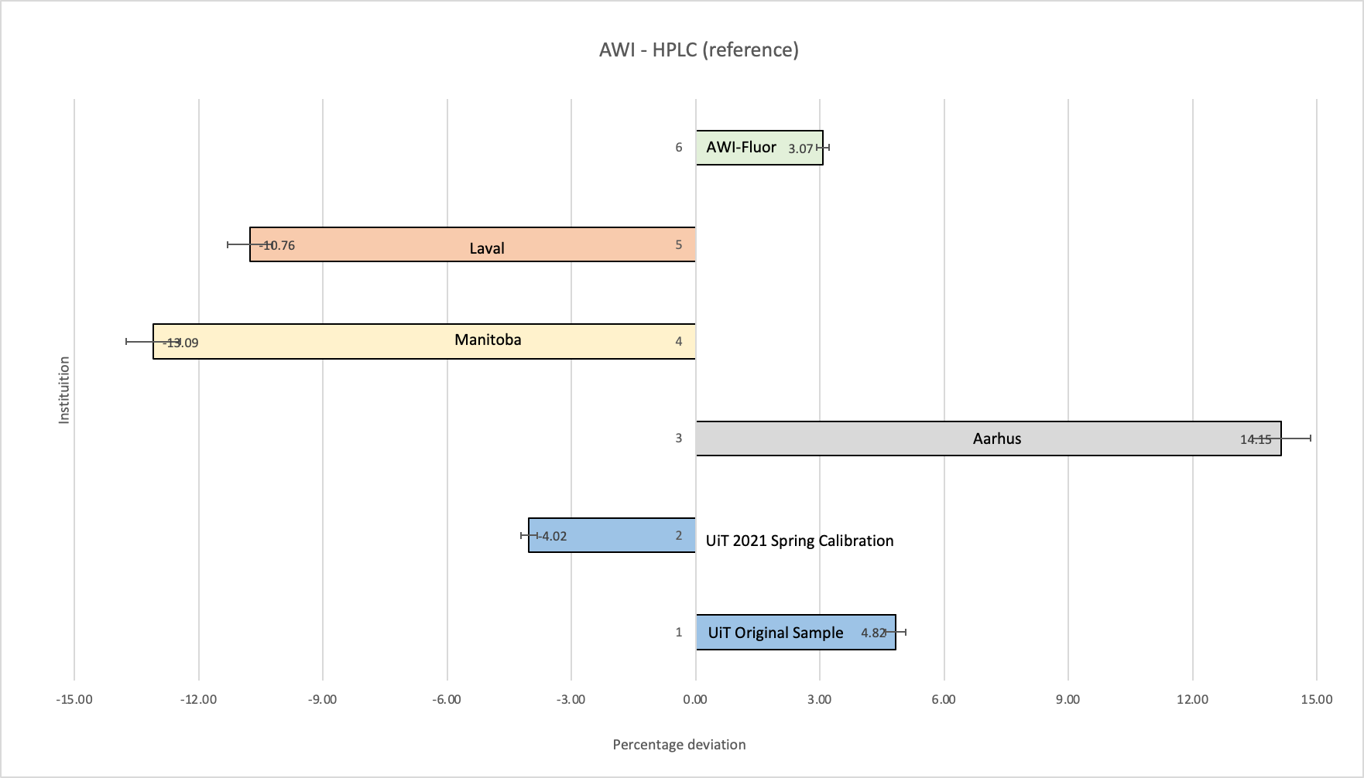
Graph 3a: Difference in percentage deviation chlorophyll a from AWI-HPLC

