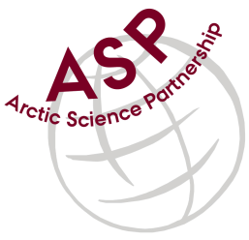

Minutes from ASP Administration & Communications Meeting

Date: May 3, 2018
Present: Peter Schmidt Mikkelsen, Linda Chow, Peter Bondo Christensen, Egon Randa Frandsen, Emma
Missing: Lene Kielsen Holm, Jennifer Hollar
Referee: Linda Chow

1. ASP Administration – General Updates/Discussion

- Invoices to ARC
- Cruise to Greenland in planning stages, shipping and buying being headed by Egon
2. ASP Communications – General Updates/Discussion

- Peter came to Winnipeg to introduce Issaffik to CEOS/University of Manitoba
- Emma mentioned that they are busy finding a suitable cruise for upcoming field season
- Emma is stepping down as head of division to concentrate on just communications
- New person to start in June
- Peter updated team that Leadership meeting will be in November in Denmark
- AWI is now a full member. Laval, Tromso, and Copenhagen in partnership
- Focus area of CERC is going from Sea ice to inland Greenland Icesheet
- Emma and Lena are working on guidelines for fieldwork, what to expect from scientists, outreach, etc

3. ASP Communications – Newsletter

- Nothing new to report – next issue will be in the fall
4. ASP Communications - Website
- Peter noted Issaffik website being updated with re-design launch in June
- ASP website has been updated

5. ASP Communications - Social Media

6. Next ASP Admin/Communication team meeting

- Thursday, June 7, 2018

