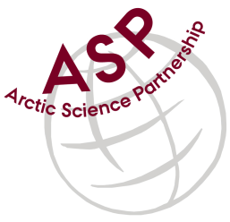

Minutes from ASP Laboratory Team Meeting

Date: December 14th, 2022
Present: Marcos Lemes (UM), Marie-Hélène (UL), and Egon Frandsen (AU), Karley Campbell (UT), Ilka Peeken (AWI), and Else Ostermann (GNI)
Absent: none
Referee: Marcos

This is meeting has been taken online.

We have discussed below topics:

- Discussed the chlorophyll data from the participants that Karley compiled and showed graphically.
- Karley had sent samples to Ilka (AWI) to analyze on Fluorometer and HPLC as well. Ilka was invited to participate on the discussion as well.
- Most of participants had loss for chlorophyll compared to what was analyzed by Karley right after the sampling. Karley mentioned that have seen up 20% loss before
- Ilka mentioned that some of differences om the results could be related to standards purchased from suppliers. She has seen concentration different from what is stated from supplier. A standardization of the purchased standard is suggested.
- Marcos will compile the data and analysis procedures in order to have big pictures of the analysis comparison.

Please use Skype link https://join.skype.com/uKv5ArcoaxDw for the meetings

All members agreed regarding the meeting dates; all online meetings will be on second week of each month on Wednesdays at 15h00 Central European Time (CET).

IMPORTANT NOTE: Next team meeting will be on January 11st 2023 at 15h00 CET

