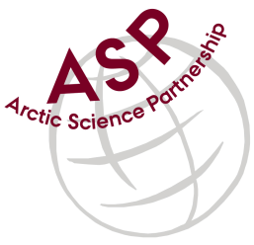

Minutes from ASP Laboratory Team Meeting

Date: April 13nd, 2024
Present: Marcos Lemes (UM) and Egon Frandsen (AU)

Absent: Karley Campbell (UiT), Else Ostermann (GNI), and Katharina Hamer (GNI), Ilka Peeken (AWI), Christien Laber (UiT), and Marie-Hélène (UL)

Referee: Marcos

This is meeting has been taken online.

We have discussed below topics:

- Egon (AU) and Marcos (UM) discussed the DIC exercise and an alternative preservation method to replace HgCl_{2.}
- Expanding DIC/TA exercise in 2024 – DFO (David Capelle) and University of Calgary (Brent Else) will join the intercalibration. Waiting for confirmation from Danish part.
- Update of some DIC information about 3% and 10% H₃PO₄ titrant. Apollo Scitech decided do a test with 3% and 10% H₃PO₄ due to our findings. We are waiting for their response.
  - Egon exchanged samples used in previous exercise with another Danish lab for comparison. He got similar data trend with new and old version DIC models (higher tendency for older model and lower tendency for newer model).
  - Marcos did a test with 3% H₃PO₄ and 10% H₃PO₄ and confirmed of high and low tendency is due to acid concentration.
- Egon informed that The University of Southern Denmark will participate in our intercomparison.
- Marcos will contact Ilka (AWI) if any laboratory is interest to participate on the intercomparison.

Please use Teams link https://teams.microsoft.com/l/meetup-join/19%3aiaBWS_EnwxKky61JDxNP89AT3vq9AlgyUTHa4FP4Xpc1%40thread.tacv2/1681337140562?context=%7b%22Tid%22%3a%224f80dd0b-338c-4e4c-8a14-90446962f7b8%22%2c%22Oid%22%3a%2271262080-0ca9-4c08-ba54-444a9d0cbce3%22%7d for the meetings

IMPORTANT NOTE: Next team meeting will be on August 8th 2024 at 15h00 CET

