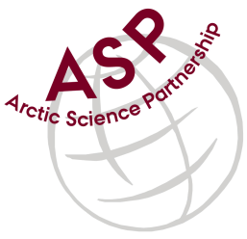

**Minutes from ASP Laboratory Team Meeting**

Date: October 10th, 2024

Present: Marcos Lemes (UM), Zoe Walker (UC), and Christien Laber (UiT).

Absent: Else Ostermann (GNI), Katharina Hamer (GNI), Sinhué Torres-Valdes (AWI), Jan Hoppema (AWI), and Björn Rost (AWI), Brent Else (UC), Egon Frandsen (AU), Carolin Löscher (SDU), David Capelle (DFO), and Kitte Gerlich (AU).

Referee: Marcos

This is meeting has been taken online.

We have discussed below topics:

* Marcos (UM) gave an update about samples collected and approximately date for shipping them.
* Four flasks of fresh water and sea water will be shipped to:
  + Fisheries and Oceans Canada (Winnipeg, Canada);
  + University of Calgary (Calgary, Canada);
  + Aarhus University – 2 laboratories - (Aarhus, Denmark);
  + University of Southern Denmark (Odense, Denmark);
  + University of Tromsø (Tromsø, Norway);
  + Alfred Wegener Institute *(*AWI) (Bremerhaven, Germany), and
  + University of Manitoba (Winnipeg, Canada).

I would like to thank you all for participating in this exercise.

Please use Teams link <https://teams.microsoft.com/l/meetup-join/19%3aiaBWS_EnwxKky61JDxNP89AT3vq9AlgyUTHa4FP4Xpc1%40thread.tacv2/1681337140562?context=%7b%22Tid%22%3a%224f80dd0b-338c-4e4c-8a14-90446962f7b8%22%2c%22Oid%22%3a%2271262080-0ca9-4c08-ba54-444a9d0cbce3%22%7d> for the meetings

**IMPORTANT NOTE**: I believe we can skip next meeting, November, and meet again in December 12th 2024 at 15h00 CET