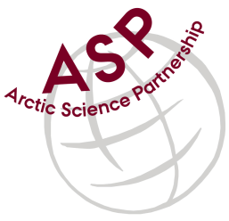

**Minutes from ASP Laboratory Team Meeting**

Date: October 12nd, 2024

Present: Marcos Lemes (UM), Zoe Walker (UC), Christien Laber (UiT), Egon Frandsen (AU), and Kitte Gerlich (AU).

Absent: Else Ostermann (GNI), Katharina Hamer (GNI), Sinhué Torres-Valdes (AWI), Jan Hoppema (AWI), Björn Rost (AWI), Brent Else (UC), Carolin Löscher (SDU), David Capelle (DFO).

Referee: Marcos

This is meeting has been taken online.

We have discussed below topics:

* Marcos (UM) gave an update on DIC and TA preservative study. The study is at 90 days preservation.
* Regarding the DIC and TA interlaboratory comparison exercise, Marcos (UM) received results from 3 laboratories and remaining laboratories expressed the plans to do the analyses but issues like instrumentation problems and parental/maternal leaves are the reasons for the delaying.

I would like to thank you all for participating in this exercise.

Please use Teams link <https://teams.microsoft.com/l/meetup-join/19%3aiaBWS_EnwxKky61JDxNP89AT3vq9AlgyUTHa4FP4Xpc1%40thread.tacv2/1681337140562?context=%7b%22Tid%22%3a%224f80dd0b-338c-4e4c-8a14-90446962f7b8%22%2c%22Oid%22%3a%2271262080-0ca9-4c08-ba54-444a9d0cbce3%22%7d> for the meetings

**IMPORTANT NOTE**: The next meeting, will be in January 9th 2024 at 15h00 CET